

ANNUAL REPORT 2020-2021

GOVT. AKBAR ALI COLLEGE
ULLAPARA, SIRAJGANJ

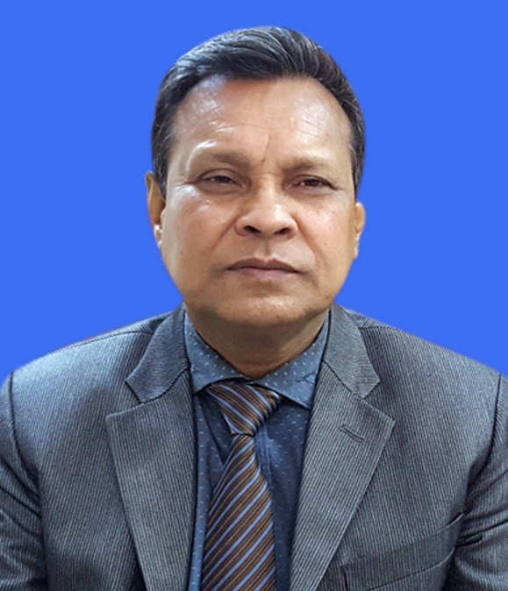

Professor Md. Ashabul Haque
Principal
Govt. Akbar Ali College
Ullapara, Sirajganj

Message
It is universally admitted that all round development of a country is impossible without necessary development in education. Ensuring quality education is one of the preconditions to reach sustainable development goals. Teachers with professional excellence and well equipped class rooms are essentially needed here. The government has rightly realized this truth. College Education Development Project (CEDP) is undoubtedly a mile-stone measure to strengthen college level education of Bangladesh.
The colleges getting IDG have got the wonderful chance to increase the professional expertise of the teachers along with decorating the class rooms with modern technological amenities. These facilities play a very vital role to meet the crisis, created due to covid-19 pandemic. Though online classes do not fully substitute the classes with physical presence, these supports at least lessened the amount of losses. These measures will of course help repair the losses in future.
Our college has been greatly benefited with CEDP. Teachers and employees have been given in-house trainings to increase their professional capabilities. Students are also benefited in many ways.
I hope that the successful implementation of this project will play a significant role to build self-reliant Bangladesh that was the dream of Bangabandhu Sheikh Mujibur Rahman, the father of our nation.

INDEX

Chapter | Contents | Page No.
Chapter -1 | Introduction | 4
Chapter -2 | Overview of the College (Institutional & Academic) | 5
Chapter -2 | Governance and Teaching Structure | 5
Chapter -2 | List of Department and others Academic Programs | 6
Chapter -2 | Key Academic Statistics | 7
Chapter -2 | Infrastructure and Facility Profile of the College | 8
Chapter -3 | Highlights of the year | 9
Chapter -3 | Key Achievements and Highlights of the year of the College | 9
Chapter -3 | Key Achievements and Highlights of the year of the Department | 9
Chapter -3 | Highlights of Student Activities of the Year | 9
Chapter -3 | Key Achievements and Highlights of the year of Institutional Development Grants (IDG) | 10
Chapter -4 | Teacher Development | 11
Chapter -4 | Overview of Teaching Force of the College | 11
Chapter -4 | Teacher Professional Development Programs | 12
Chapter -4 | Highlights of Teacher Development Activities of the Year | 12
Chapter -5 | Budget and Finance | 13
Chapter -5 | Summary of Annual Budget and Expenditure | 13
Chapter -5 | Summary of Annual Revenue | 14
Chapter -6 | Concluding Remarks | 15
Chapter -6 | Overall Assessment of Performance of the last year and Key Target for the Next Year | 15
Chapter -6 | Key Challenges and Risk for the College | 16
Chapter -6 | Recommendation | 17
Chapter-7 | Photo Gallery | 18

Chapter 1
Overview of the College (Institutional & Academic)

Sirajganj district is known as the gate way to North Bengal. Govt. Akbar Ali College is an acclaimed name in the north part of Bangladesh that has achieved a unique position in this area for its eminent role in spreading education in rural area. The college established in 1970 by some local elite persons. In 1984 the college is nationalized by the government of Bangladesh. The college is running successfully its academic activities including Science, Business Studies, Humanities at HSC level; BA, BSS, BBS & BSc, Bachelor Degree (Pass) course, Honours in Bangla, English, Economics, Political Science, Philosophy, History, Islamic History & Culture, Physic, Chemistry, Botany, Zoology, Mathematics, Accounting & Management. Thereby the college is providing education more than 10,000 (Ten Thousand) students. The running Principal heartiest cordiality have turned the college into a sanctuary for the meritorious students. There are two hostel, accredited for HSC, Degree (Pass) & Honours students, running successfully. To encourage cultural activities, the college arranged many cultural programs. The college campus has been gorgeously decorated with many of its rebuilding and infrastructural development initiatives. The institution is recognized as the best for taking education in this area in respect of passing rate & obtain GPA 5. Every year the student of this college take place in reputed public & private Universities, Medical College, Engineering University as well. With regard to securing first class in Honours & Degree (Pass) course, its success in noteworthy. It is furnished with a rich library, Mosque, a big play ground, pond and Bangabandhu Kornar in campus arena. Moreover, BNCC & Rover Scout are very active in the campus. The number of participant in many literary & cultural activities, Science Fair & Ekush Boi Mela are higher than that of any other institution of the District. The student of this college actively take part in many national level competition and earn distinction every year. It is worthy mentioned that many former & present students of the college have themselves engaged in many humanitarian activities uploading the spirit of our liberation war. This great institution is expending its influence over the family, society, country as well as the world.

2.1: Governance and Teaching Structure:
There are a Principal, a Vice Principal, 14 Associate Professor, 14 Assistant Professor, 28 Lectures and 03 Demonstrators’ post in the teaching structure of this college. There are 09 office staffs for running the office of the college smoothly. The department wise list of the teaching staffs and office staffs are given below.
Department wise Teaching Staffs
S.L | Name of post | Professor | Associate Professor | Assistant Professor | Lecturer | Demonstrator
01. | Bangla | 01 | 01 | 01 | 02 | -
02. | English | 01 | 01 | 01 | 02 | -
03. | Economics | -- | 01 | 01 | 02 | -
04. | Political Science | - | 01 | 01 | 02 | -
05. | Philosophy | - | 01 | 01 | 02 | -
06. | Islamic History and Culture | - | 01 | 02 | 02 | -
07. | History | - | 01 | 00 | 02 | -
08. | Physics | - | 01 | 01 | 02 | -
09. | Chemistry | - | 01 | 01 | 02 | -
10 | Botany | - | 01 | 01 | 02 | 01
11 | Zoology | - | 01 | 01 | 02 | 01
12 | Mathematics | - | 01 | 01 | 02 | -
13 | Accounting | - | 01 | 01 | 02 | -
14. | Management | - | 01 | 01 | 02 | -

Office Staffs
Sl No. | Name of the post | Number
01 | Physical Teacher ( College) | 01
02 | Assistant Librarian cum cataloger | 01
03 | Head Assistant | 01
04 | Accountant | 01
05 | Office Assistant cum computer operator | 05
06 | Expert Bearer | 03
07 | Office Assistant | 13
08 | Cash Pion | 01
09 | Sweeper | 01

2.2: List of Department and Others Academic Programs

There are 14 departments in this college. In the academic year 2020-2021, a total no of 1373 students were admitted in Honours levels. Beside this 643 student were also admitted in Degree (pass) course. Furthermore, about 945 students were admitted in the HSC level. List of the department wise enrolled students and the teachers teaching in the department are given below:
No. of Students Enrolled in Honours courses.
S.L | Department name | of students enrolled | Teachers
01. | Bangla | 84 | 05
02. | English | 101 | 05
03. | Economics | 97 | 04
04. | Political Science | 101 | 04
05. | Philosophy | 133 | 04
06. | Islamic History and Culture | 102 | 05
07. | History | 100 | 03
08. | Physics | 78 | 04
09. | Chemistry | 92 | 04
10. | Botany | 78 | 04
11. | Zoology | 88 | 04
12. | Mathematics | 74 | 04
13. | Accounting | 121 | 04
14. | Management | 124 | 04

No. of Students Enrolled in Degree (Pass) courses.
S.L | Department name | No. of Students Enrolled
01 | BA | 280
02 | B.S.S | 293
03 | B.B.A | 55
04 | B.Sc | 15

2.3: Key Academic Statistics
The result of this college at different level is satisfactory. In Degree (Pass Course) the pass rate is
85% in Honours 69%. The Teacher –Student Ratio is 1: 250.

Sl No. | Course | Year | Pass Rate (%)
01 | HSC | 2020 | 100
02 | Degree | 2019 | 85
03 | Honours | 2019 | 69

Figure: Passing rate of different courses

2.4: Infrastructure and Facility profile of the college
There are 10,000 students studying in this college. The institution has the following Infrastructure and Facility Profile.
Sl No. | Name |  | No
01 | No. of Class Rooms |  | 21
02 | Boys Dormitories |  | 01
03 | Girl’s Dormitories |  | 01
04 | Teachers’ Dormitories |  | 00
05 | Computer Lab |  | 01
06 | Science Lab |  | 06
07 | Auditorium |  | 00
08 | Gymnasium |  | 00
09 | Library | Central | 01
09 | Library | Seminar | 14
10 | Boy’s Common Room |  | 01
11 | Girl’s Common Room |  | 01
12 | Teachers Room : |  | 01
13 | Toilet |  | 40
14 | Internet Access Facilities |  | All teachers avail Internet facilities in the campus
15 | Multimedia Projector |  | 17
16 | Wi-Fi Facilities |  | 14 departments have Wi-Fi facilities.

Chapter 2: Highlights of the year
3.1: Key Achievements and Highlights of the Year of the College

Academic:
- Examination results: 75% participant in the online final exam with pass rate of 92%
- Attendance: 55 % (in on Line Classes)
- Classroom Performance: Immeasurable due to absence of physical classes.
- Online Classes: Due to Covid-19 pandemic situation, the online classes have been started and carried forward.
Technological Development:
The surveillance system of all of the building and campus is improved by the use of CC Camera. In addition to this there is a Vigilance system where the teachers are vigilance during the class time.
Non-cognitive factors:
Self-Efficacy: Students believe in his /her own ability to succeed in a particular situation which is called self-efficacy has been developed a lot through counseling to face the challenges in technological oriented education system.
Mentor: Students are grouped under a teacher called Mentor who consults the students.
Motivation: Constant motivation is going on to actively take part in the process of learning as motivation involves physical, mental, social and cognitive forces, teachers are constantly engaged in initiating and encouraging those faculties.

3.2: Key Achievements and Highlights of the Year of the departments:
All the department arranged different programs to observed national days and commemorating the century birth anniversary of the father of the nation, Bangabandhu Sheikh Mujibur Rahman. Due to COVID-19 situation, all the departments continued their academic activities through virtual platform.

Academic:
* Classroom performance: Classroom performance is an example of student response system. It is the key learning. It allows the student to take part actively in the process of learning. Still our studentsare less inquisitive, but we have been trying to encourage them asking question which are most important factor of inquisitiveness and student are gradually responding to this system.
* Sitting for examination (Internal/External): Sitting for examination is the conventional feedback of learning system. Though it is directly related to academic recognition, students are very keen to attend all kinds of feedback on examination performance. Here the participant of the learners is almost 100%.
Extra-Curricular Activities:
- Sports: We arrange Inter Department T-20 Cricket competition on the commemorating the century birth anniversary of the father of the nation, Bangabandhu Sheikh Mujibur Rahman.
- Cultural Activities: Cannot be arranged due to the pandemic situation.
- Social Activities: Rover Scouts distributed food &necessary items for poor day basis employees of the college in corona pandemic situation. BNCC & Rover Scout Also play roles to keep the campus clean and take part disciplinary activities and march-past during the celebration of the national days.
- Civic Engagement: In the last year our student volunteered in some social awareness programs like Blood Donation, Hand Wash, Wearing of Mask etc.

3.4: Key Achievements and Highlights of the year of Institutional Development Grants (IDG).
One OTM package W-1 and Three RFQ package was completed the last year. The RFQ package includes the procurement of one Diesel Generator, Two Submersible pumps &near about 1400 hundred books. The college also got IT equipment such as 28 Desktop & 28 Laptop computers, o1 Photocopier, 01 Printer, o1 Scanner procured by PMU as central procurement.
With the implementation of the OTM works package (W-1) all of 14 Department office, 14 Seminar rooms, 21 Class rooms, 01 Computer lab, 06 Science lab, Office room, BNCC Office, Scout Office, Central Library, Girls’ Common room, Girls & Boys wash room etc. have been renovated with tiles.

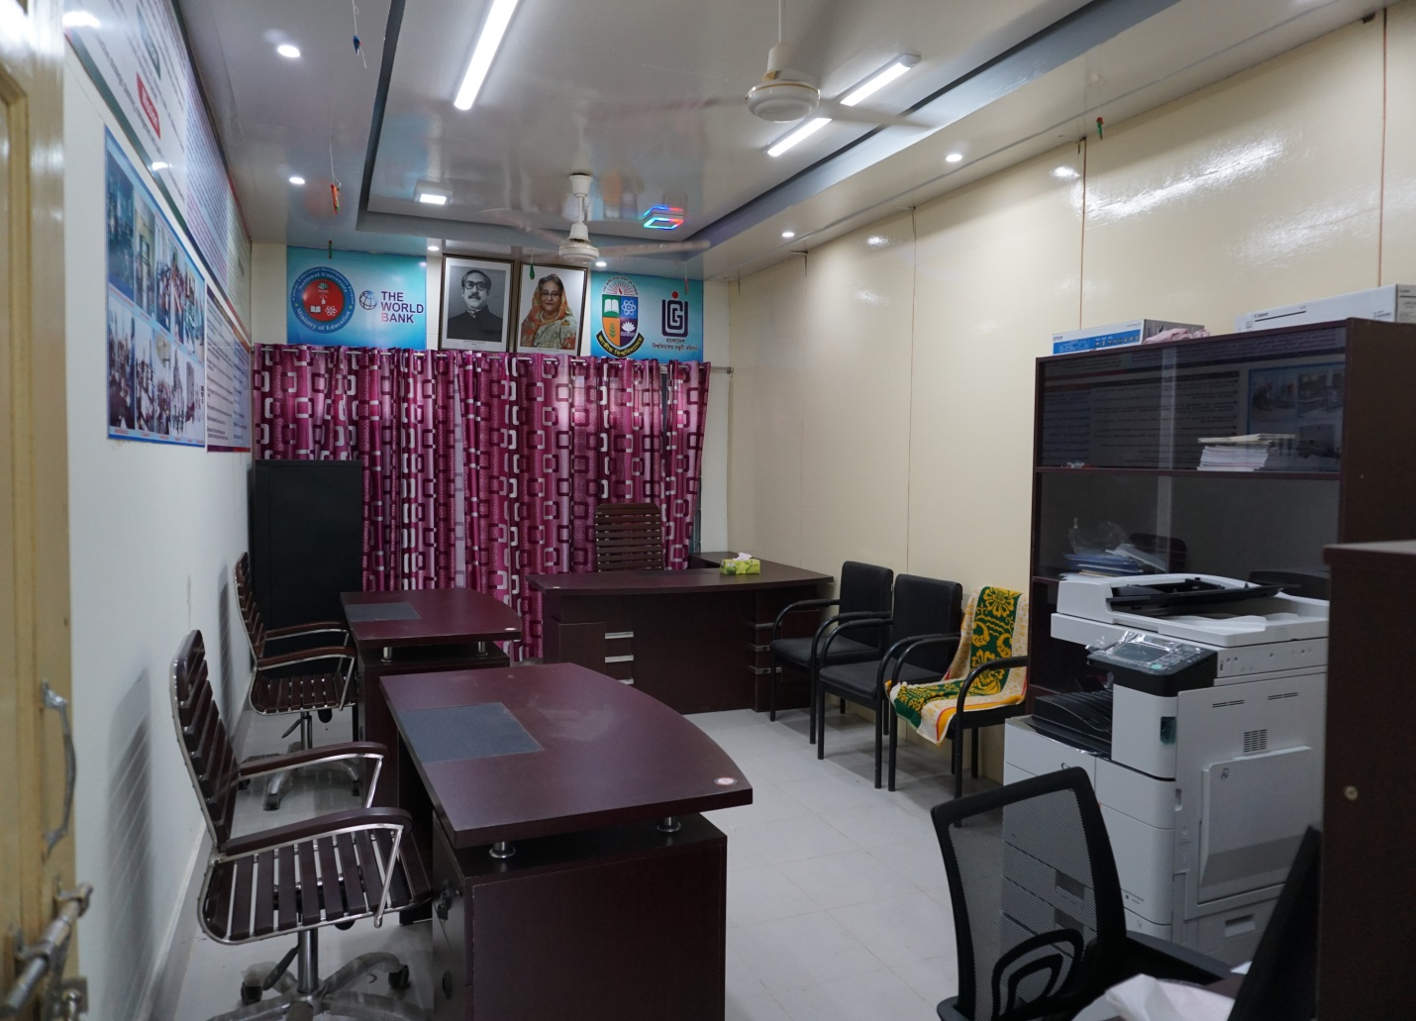

CEDP Sub Project Office

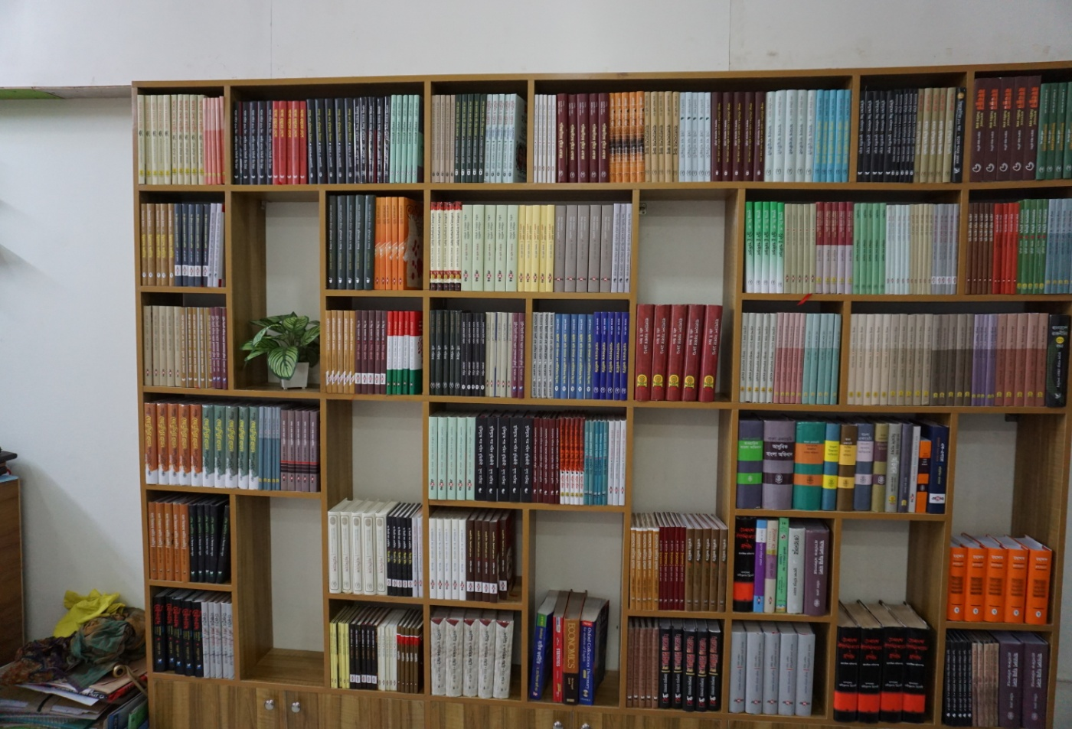

Book Purchased under CEDP

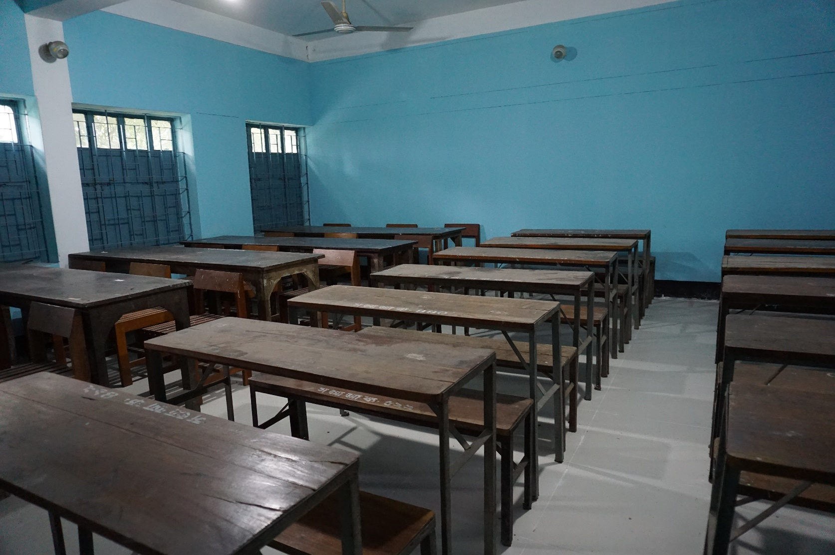

Renovation & refurbishing of Class Rooms

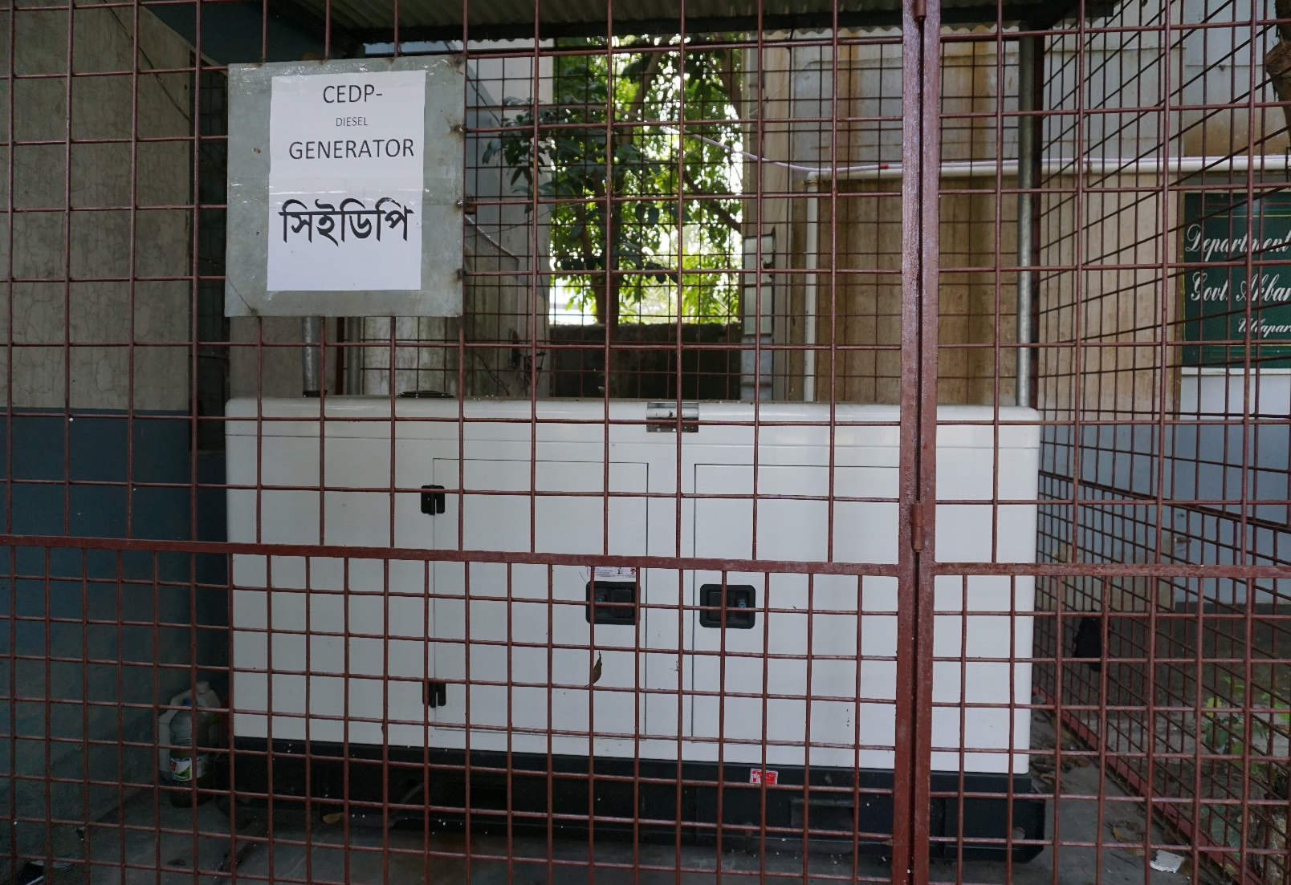

Diesel Generator purchased under CEDP

Chapter 3: Teacher Development
4.1: Overview of Teaching Force of the College
Both Male and Female Teachers are teaching in the college. In the college, there are 58 post and present 44 teachers are teaching 14 post are lying vacant. An overview of the teaching force of the college is as follows.

No. of Teachers by subject & gender

S.L | Department name | No. of Male Teachers | No. of Female Teachers | No. of Teachers
01. | Bangla | 04 | 01 | 05
02. | English | 03 | 01 | 04
03. | Economics | 03 | 00 | 03
04. | Political Science | 03 | 00 | 03
05. | Philosophy | 03 | 00 | 03
06. | Islamic History and Culture | 05 | 00 | 05
07. | History | 03 | 00 | 03
08. | Physics | 03 | 01 | 04
09. | Chemistry | 02 | 01 | 03
10. | Botany | 02 | 01 | 03
11. | Zoology | 00 | 01 | 01
12. | Mathematics | 01 | 00 | 01
13. | Accounting | 02 | 00 | 02
14. | Management | 03 | 01 | 04

No. of Post at a Glance
Name of the post | Created post | Posted Teachers | Vacant Post
Principal | 01 | 01 | 00
Vice principal | 01 | 00 | 01
Professor | 02 | 01 | 01
Associate Professor | 14 | 12 | 02
Assistant Professor | 14 | 10 | 04
Lecturer | 28 | 20 | 08
Demonstrator | 02 | 01 | 01
Assistant Librarian | 01 | 00 | 01
Total = | 63 | 45 | 18

4.2: Teacher Professional Development Programs

ICT Training (In-House): In the last fiscal year, an in-house training program on ICT was conducted in the college ICT lab to enhance technological competence of the teachers. 30 teachers participated in the training course.

4.3: Highlights of Teacher Development Activities of the Year.
Abroad training: Two teachers have taken abroad training in Nottingham University (Malaysia Campus). One teacher has got M.A Degree in Education with merit under CEDP.
Online Classes: During the COVID-19 period teachers show their expertise in conducting online classes.

Chapter 4: Budget and Finance
5.1: Summary of Annual Budget and Expenditures
Descriptions of total allocation & expenditure of the fiscal year 2020-20 are given below:
Financial Code | Salary & Allowances | Allocation | Expenditure
31 | Rewards of Staffs
3111101 | Basic Salary of the officers | 3,38,64,000/- | 2,76,30,144/-
3111201 | Basic Salary of the Staffs | 24,51,000/- | 23,11,963/-
3111302 | Travel Allowance | 1,00,000/- | 67,844/-
3111306 | Education Allowance | 3,00,000/- | 2,22,000/-
3111310 | Housing Rent Allowance | 1,02,96,000/- | 91,00,629/-
3111311 | Medical Allowance | 12,01,000/- | 9,46,500/-
3111312 | Telephone Allowance | 78,000/- | 68,000/-
3111314 | Tiffin Allowance | 26,800/- | 26,800/-
3111316 | Washing Allowance | 11,500/- | 11,100/-
3111325 | Festival Allowance | 50,58,289/- | 42,19,220/-
3111328 | Rest and Recreation Allowance | 8,87,000/- | 8,86,990/-
3111335 | Bangla New Year Allowance | 13,06,000/- | 4,28,832/-
3111338 | Others Allowance | 1,90,000/- | 109,092/-
3211113 | Electricity | 4,50,000/- | 2,49,776/-
3211117 | Internet/Telex/Fax | 35,000/- | 35,000/-
3211119 | Postal | 5,000/- | 0.00/-
3211120 | Telephone | 15,000/- | 5,423/-
3211127 | Books and Magazines/---- | 90,000/- | 89,187/-
3243101 | Gas & Fuel  (Printing and Stationaries) | 90,000/- | 89,187/-
3255101 | Computer Accessories  (Printing and Stationaries) | 40,000/- | 39,750/-
3255105 | Other Stationaries  (Printing and Stationaries) | 1,00,000/- | 99,941/-
3256102 | Chemicals | 1,50,000/- | 2,70,000/-
3256103 | Usable Articles | 75,000/- | 74,986/-
3256106 | Dress (Materials) | 75,000/- | 74,655/-
3256107 | Sports Items | 75,000/- | 74,110/-
3257301 | Furniture | 10,000/- | 10,000/-
38 | Other Expenditures
3821101 | Land Development Tax | 30,000/- | 28,860/-
3221103 | Corporation | 9,00,000/- | 6,39,550/-
41 | Financial Assets (Capital Expenditures)
4112306 | Laboratory Equipment’s | 3,20,000/- | 3,20,000/-
4112312 | Education and Educational Materials | 85,000/- | 84,914/-

5.2: Summary of Annual Revenues
Due to COVID-19 pandemic situation, no enrollment was possible. Hence the tuition and admission fees collect from the students in the fiscal year 2019-2020 are below:
Year | Session | No. of Student
Honours 1st Year | 2019-20 | 2118
Honours 2ndYear | 2018-19 | 2071
Honours 3rdYear | 2017-18 | 1357
Honours 4thYear | 2016-17 | 877

Year | Session | No. of Student
Class XI | 2019-20 | 945
Class XII | 2018-19 | 929

Chapter 5: Concluding Remarks

6.1: Overall Assessment of Performance of the Last year and Key Target for the Next Year
Our teachers and employees showed their devotion, responsibility and patriotism with creative and innovative skill in continuing academic and official works in the pandemic situation. They showed their keen responsibility and accountability in profession. They also developed problem solving and inter personal skills.
If the pandemic situation continues, we must carry on the technology –assisted programs to ensure the virtual attendance, punctuality, productivity of quality work, mutual cooperation, coaching and training skills and so on.
We will arrange more in-house training programs, national and international webinars, cultural competition on virtual platforms, awareness programs and so on.
Evaluation system will be introduced to ensure the professional commitment of the teachers and the employee as well.
6.2: Key Challenges and Risks for the College
Risk Factor:
* Lack of justification system of academic performance.
* We need change our mind to adapt modern technology.
* Help to boast up self-respect and level of confidence.
* Education-friendly environment is need.
* To develop teaching skill, need more training.
Feedback Key Challenges:
* Overcoming the academic loss during COVID-19 period
* Enhancing classroom performance
* Setting up technology based classroom
* Developing behavioral pattern and cultural attitude
* Increasing guardian’s involvement
* No students should be left behind

6.3: Recommendations:

To success IDP sub-project in college level, we need more effort to supply central procure goods such as Campus networking, Connectivity of internet, Student management software, Office management software, Desktop, Laptop and Smart Board. If we want to improve our teaching learning environment, we need technology based class room in this pandemic situation.

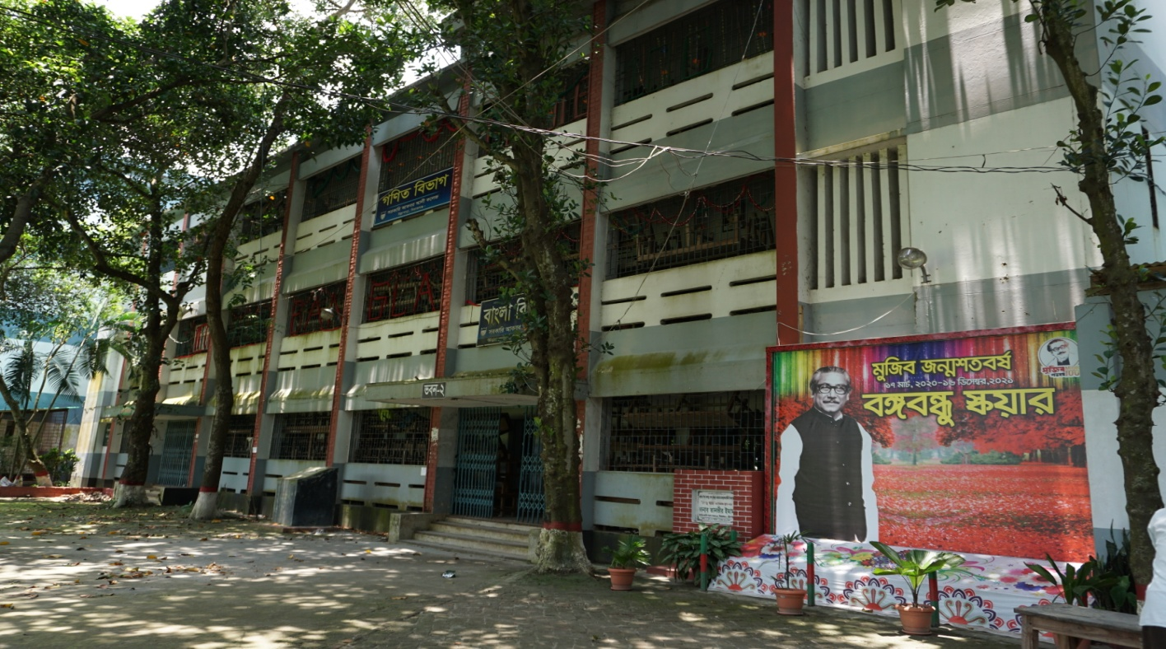

Building No. 02

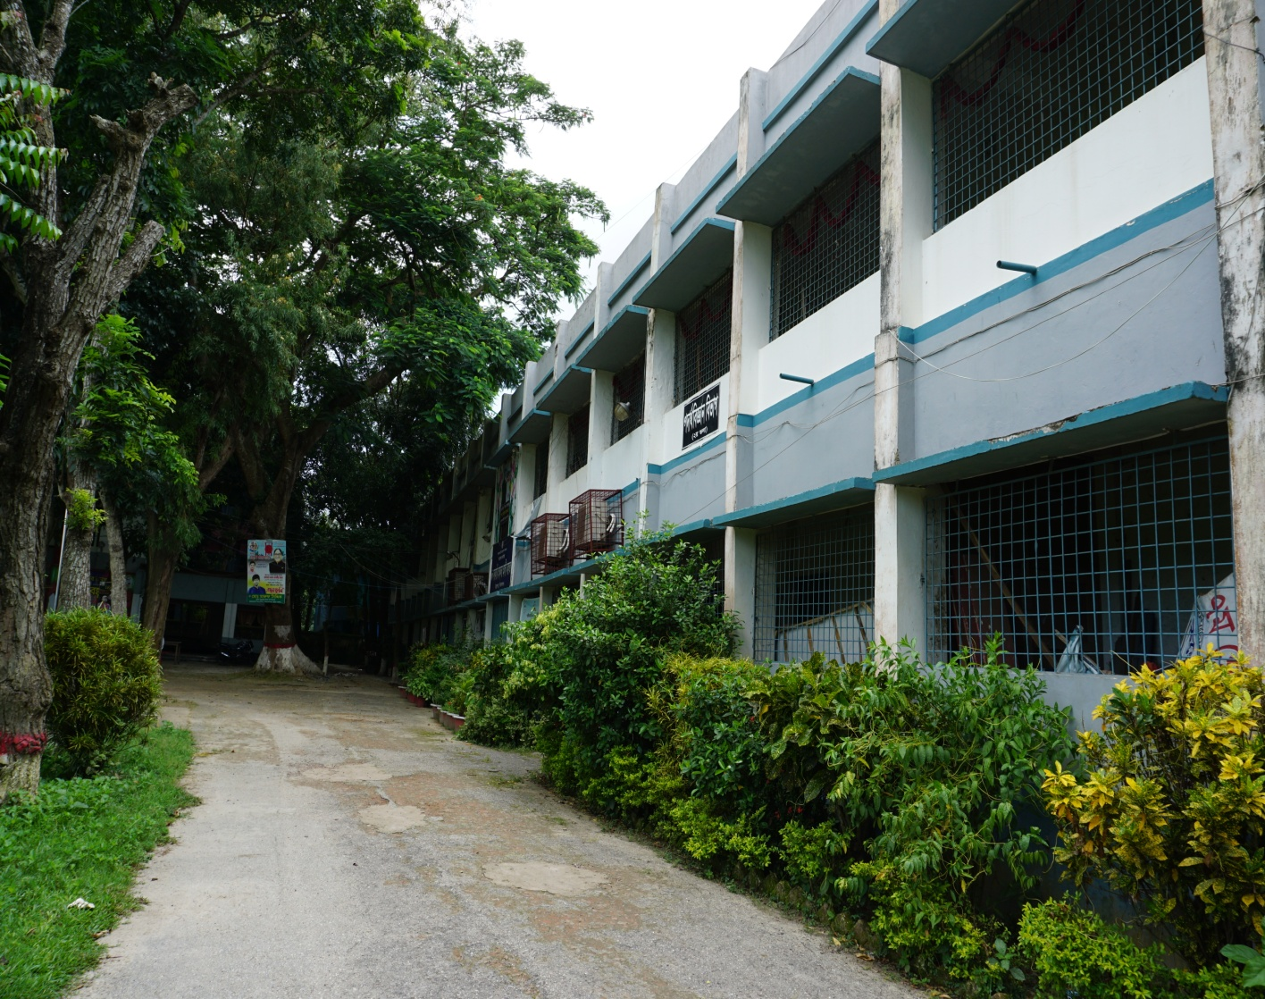

Building No. 03

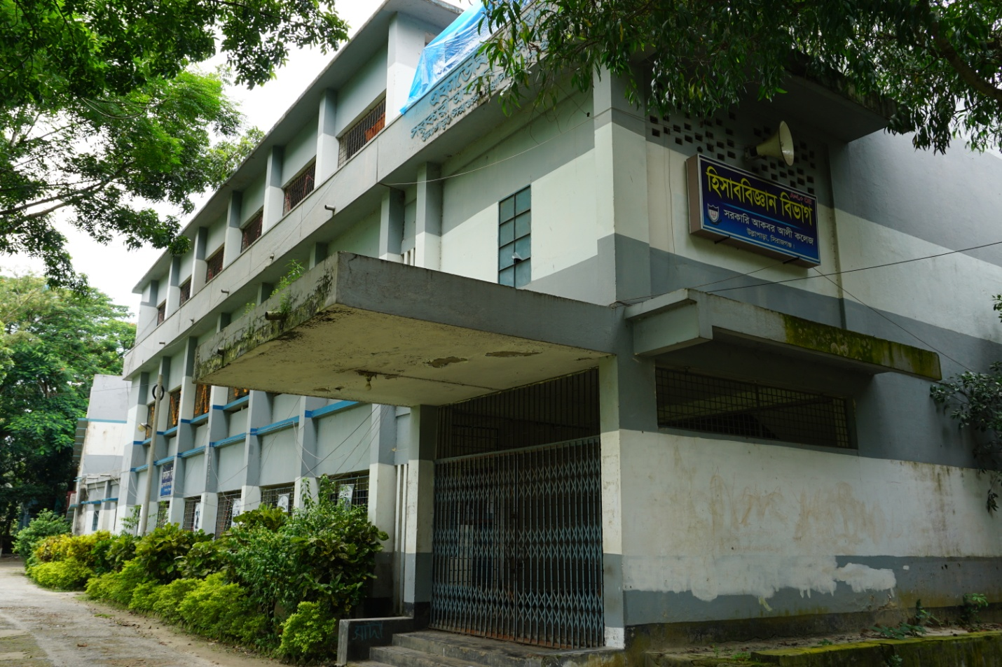

Building No. 04

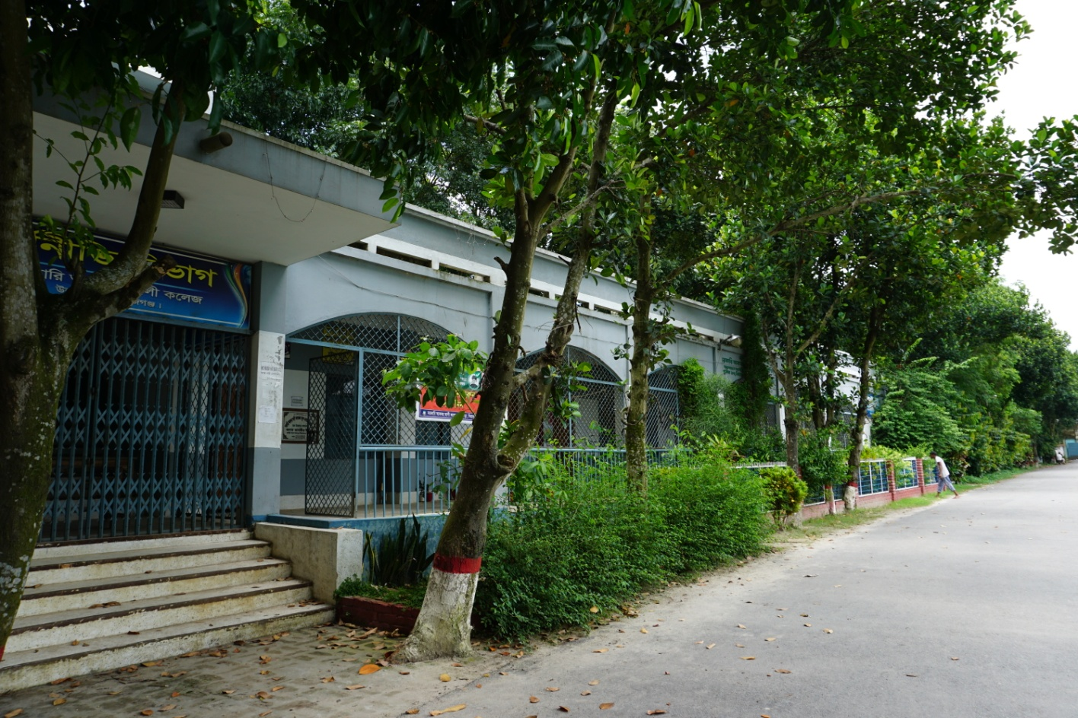

Building No. 06

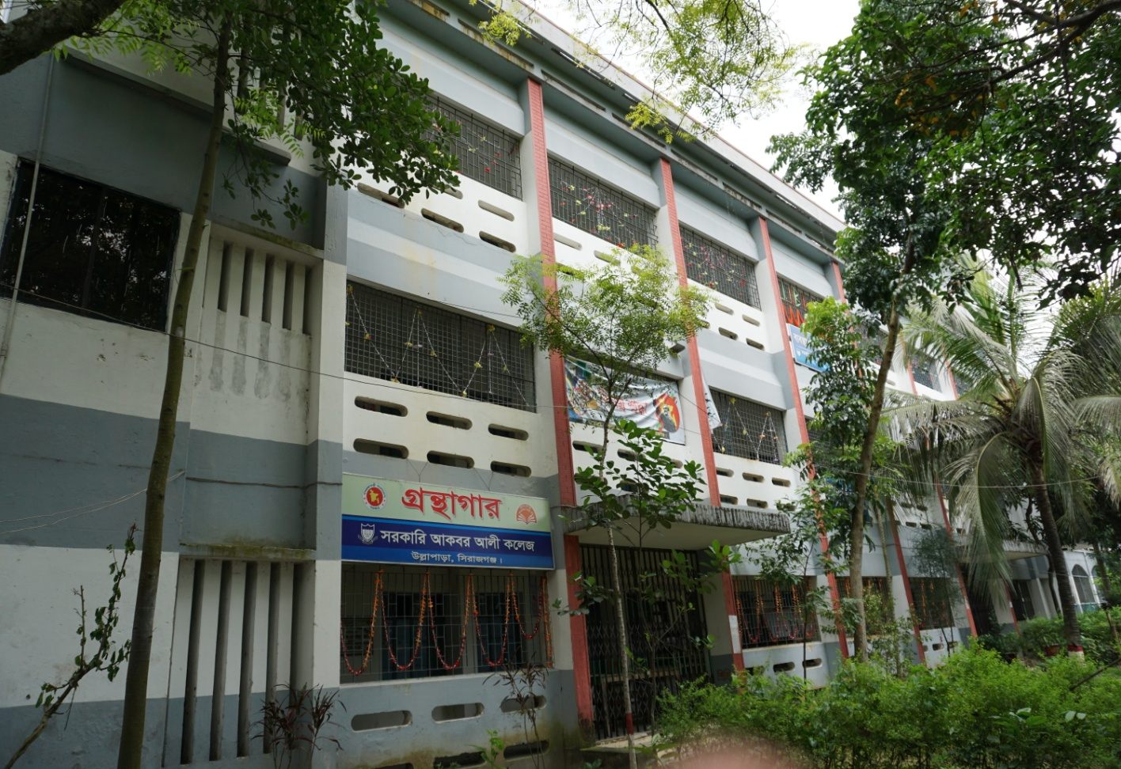

Building No.05

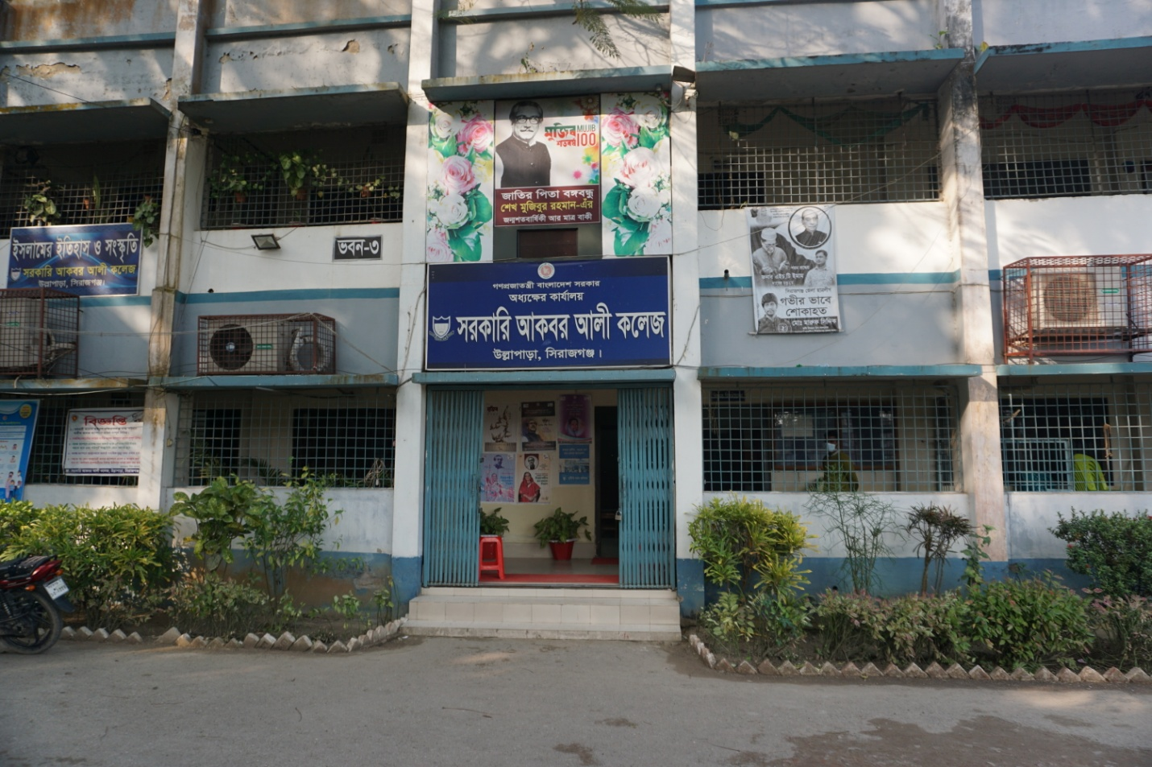

Administrative Building

CEDP Office

Books purchase under CEDP

Class rooms renovation under CEDP

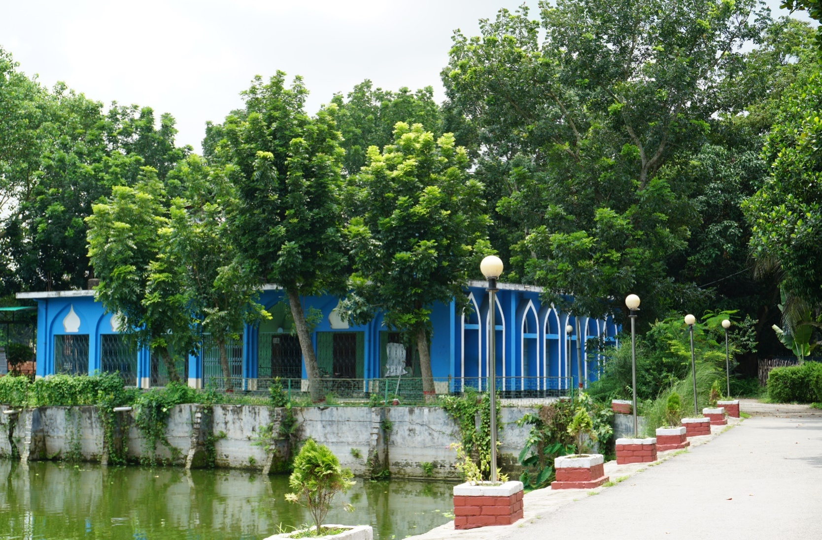

College Mosque

Diesel Generator purchased under CEDP

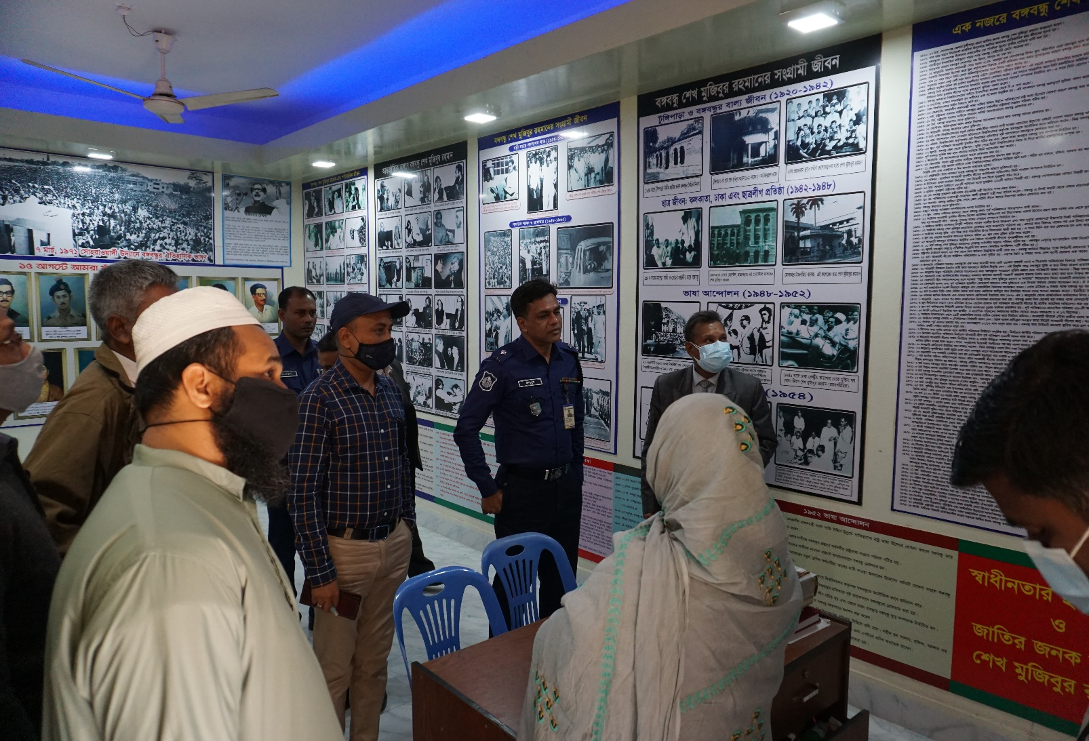

Bangabandhu Corner

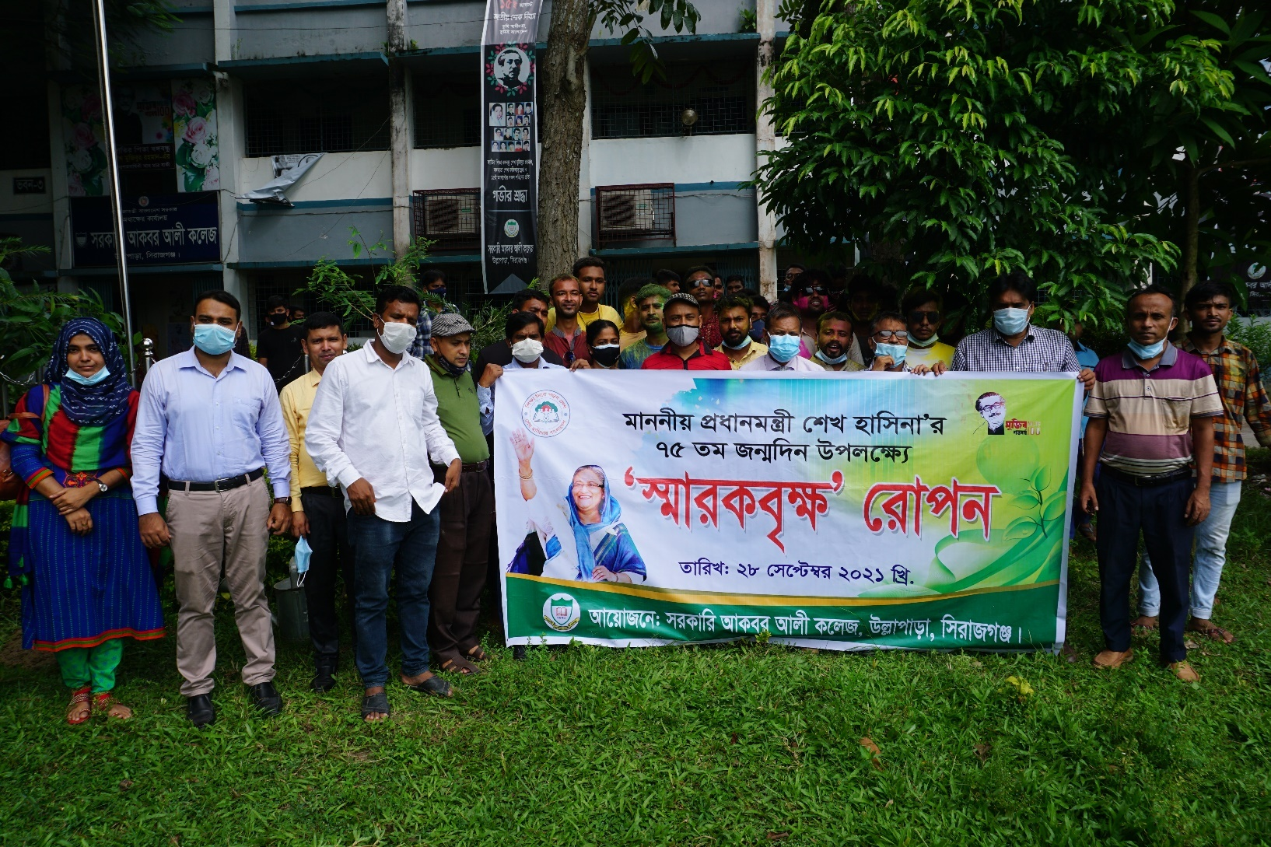

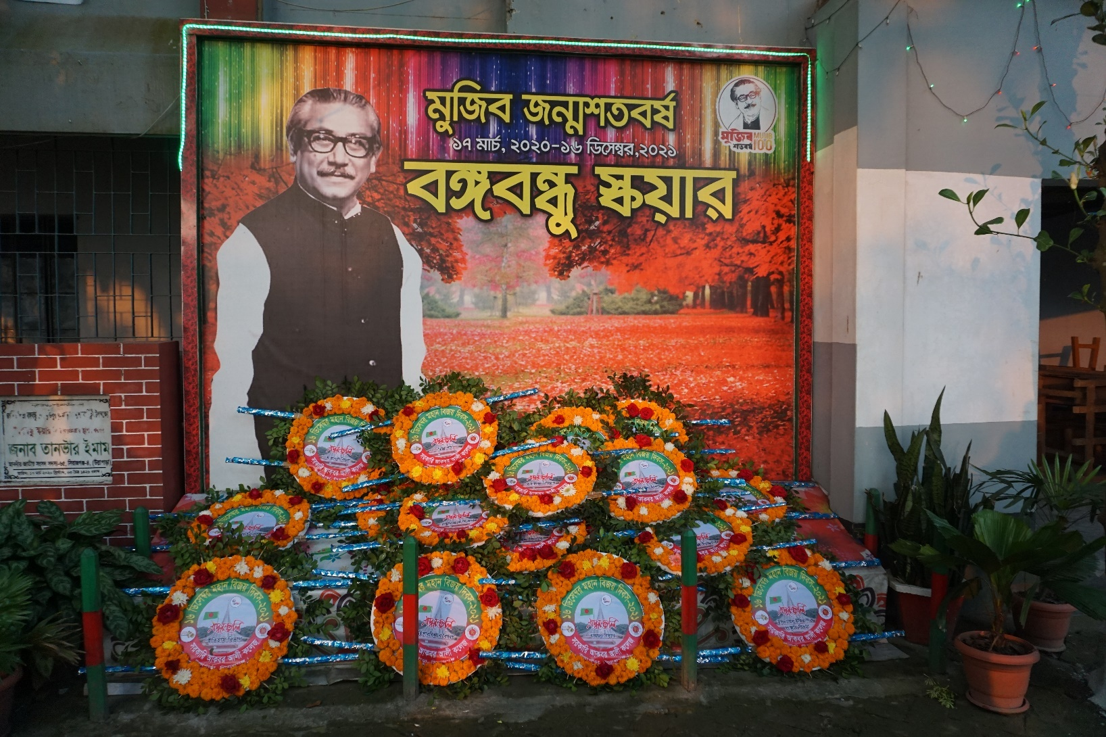

Bangabandhu Square

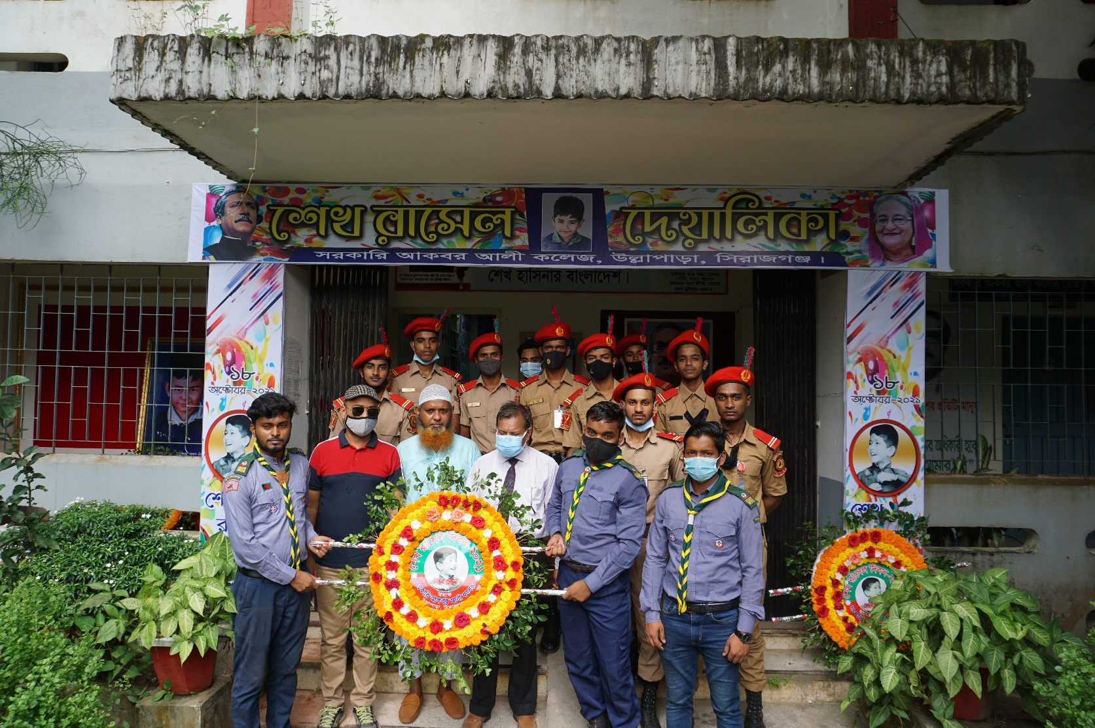

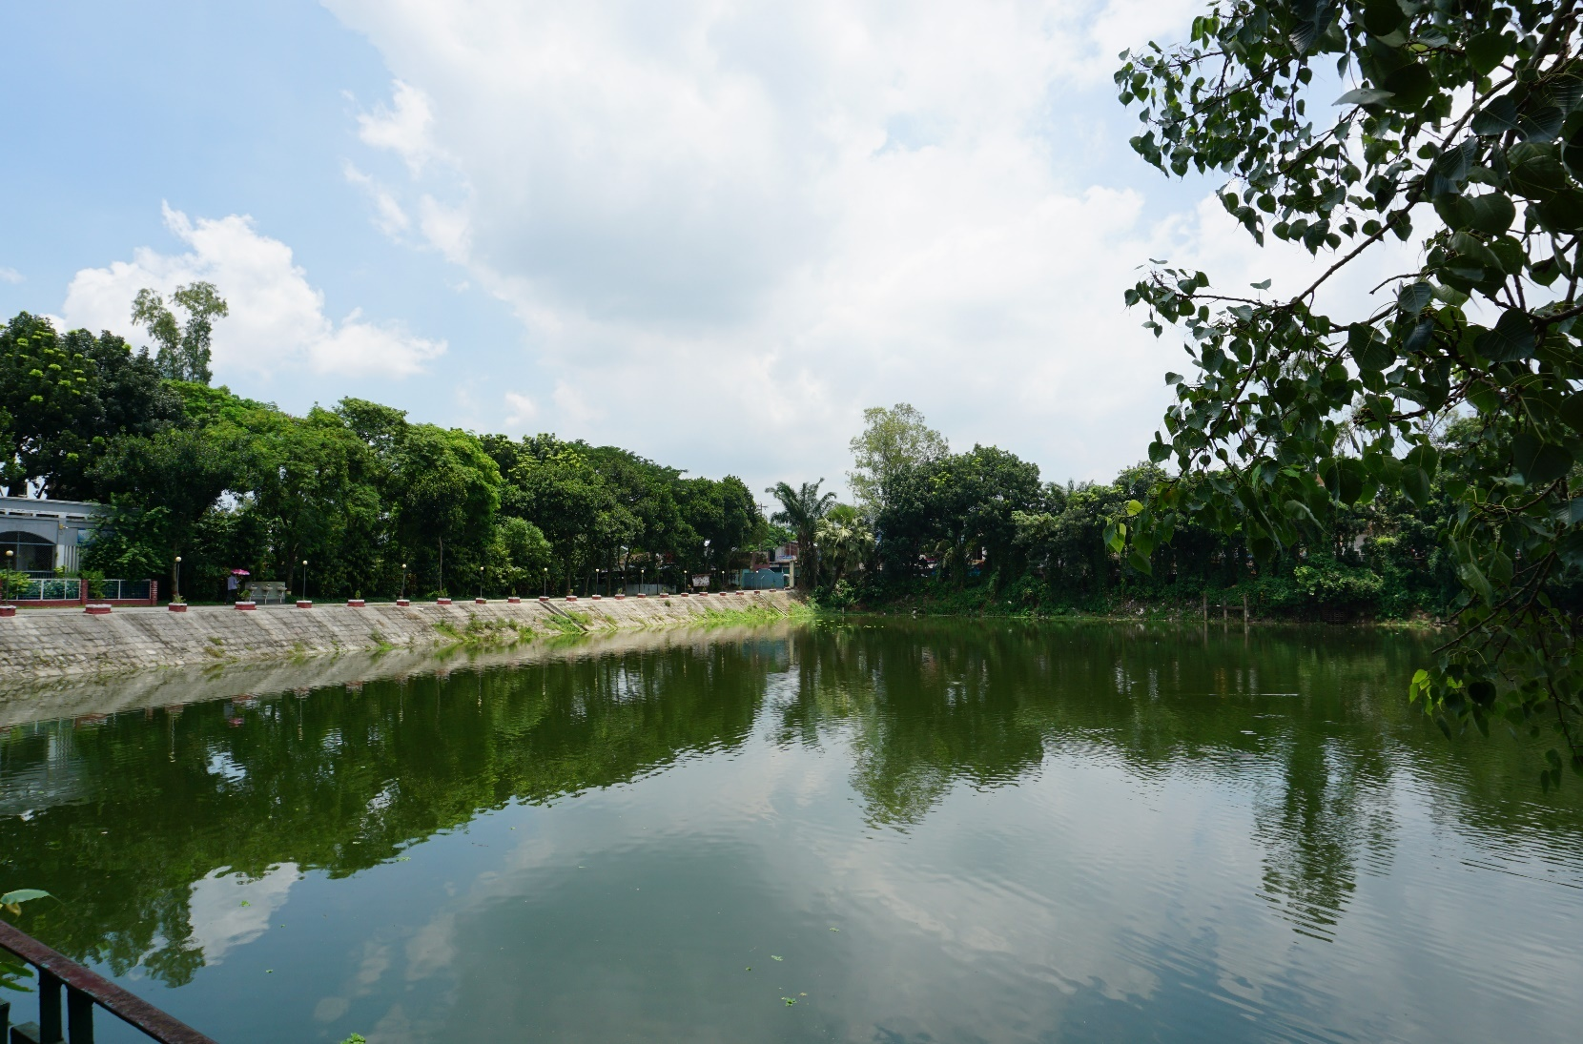

Pond at the entrances of the College

